Module 5 – Advanced Data Manipulations in Tableau

5.1 Marks and Highlight
What is Marks Card?
The Marks Card in Tableau controls the appearance of data in a visualization.
You can change:
- Color
- Size
- Shape
- Label
- Detail
- Tooltip
Types of Marks
- Automatic
- Bar
- Line
- Area
- Square
- Circle
- Shape
- Text
- Pie
- Gantt
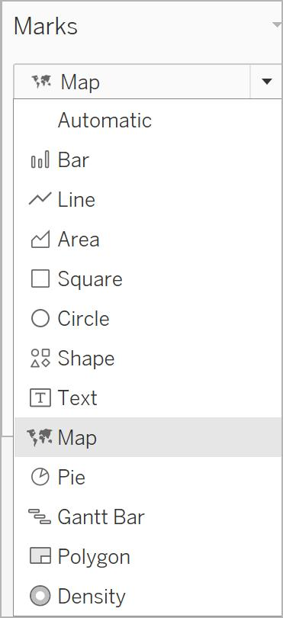
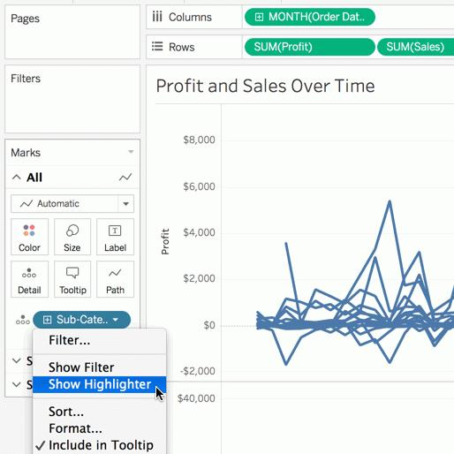
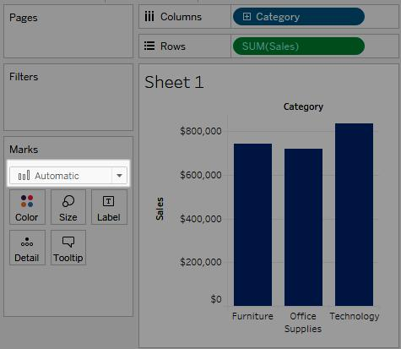

Steps to Use Marks Card
- Open Tableau worksheet
- Drag dimensions and measures
- Locate Marks Card
- Select mark type
- Customize:
  - Color
  - Size
  - Label
  - Tooltip
Highlighting Data
Highlight helps focus on selected values.
Steps for Highlight
- Create chart
- Click a mark
- Select Highlight
- Related data becomes highlighted
Example
Highlight sales of a specific region.
Move mouse over the color legend on the right side.
Click any color/category like First Class.
Also go to Highlighter choose order priority or segment or ship mode
And click on bar in graph.

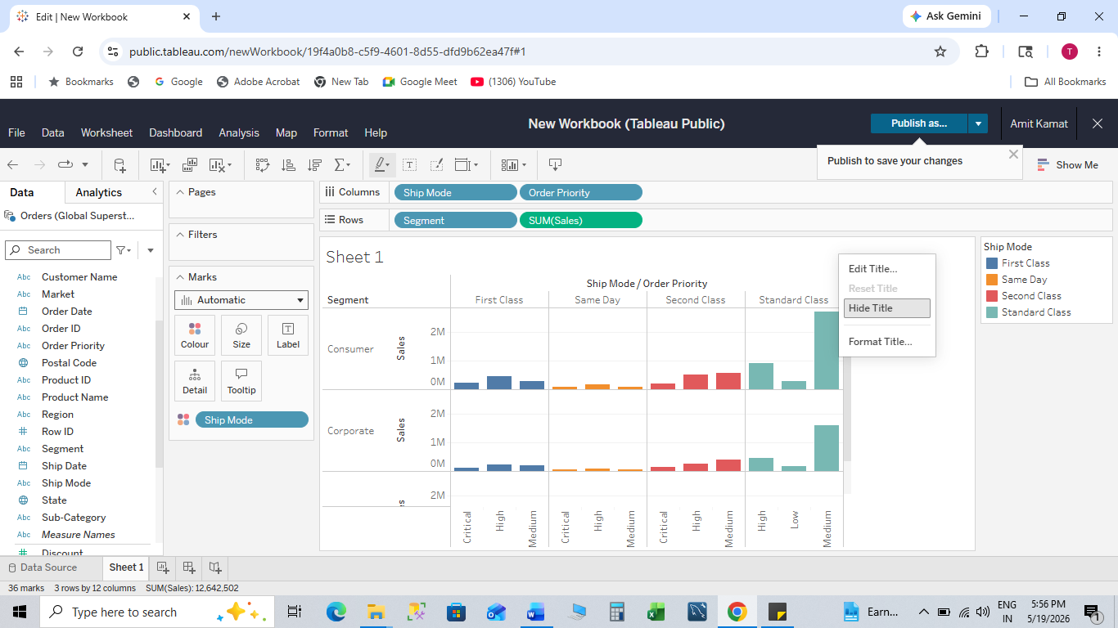

5.2 Groups
What are Groups?
Groups combine multiple dimension members into a single category.
Example:
- Bihar + Jharkhand = East Region
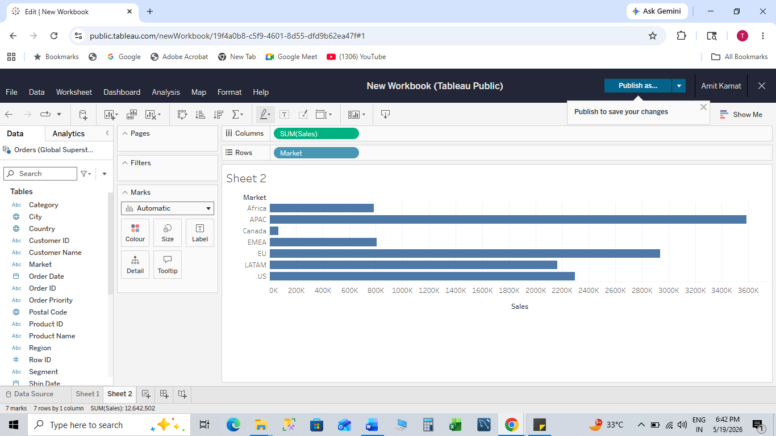
Select Africa and press ctrl+APAC
Right click and select group

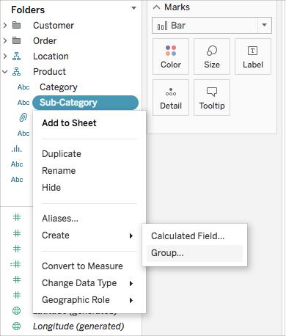
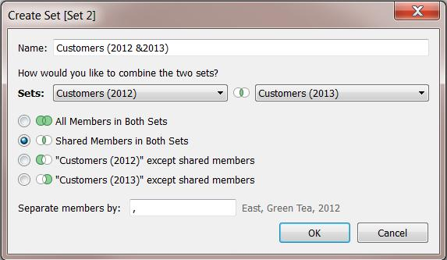
Steps to Create Groups
- Select multiple dimension values
- Right-click
- Click Group
- Rename group
Example
Combine:
- Phones
- Accessories
into “Electronics”
Benefits
- Simplifies analysis
- Reduces clutter
- Creates custom categories

5.3 Sets
What are Sets?
Sets are custom subsets of data.
Example:
- Top 10 Customers
- High-profit products
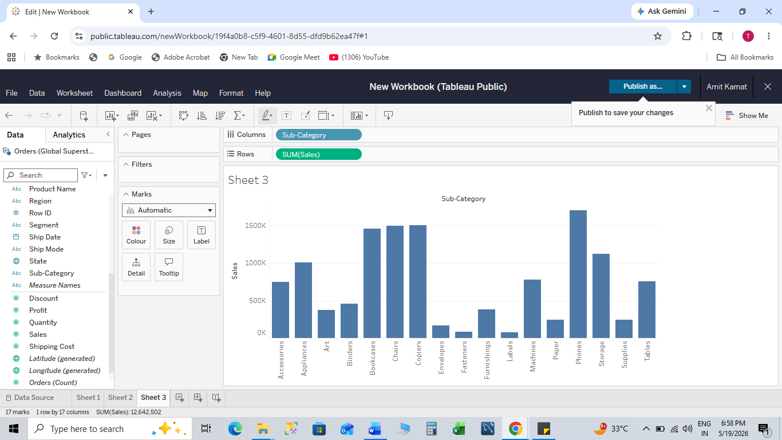
Left click in canva and select the bar , it’s create sets

Types of Sets
1. Constant Sets
Fixed members.
Example:
- Selected cities permanently included.
2. Computed Sets
Dynamic sets based on conditions.
Example:
- Sales > 50,000
3. Combined Sets
Combination of two sets.
Example:
- Top Customers AND Technology Products
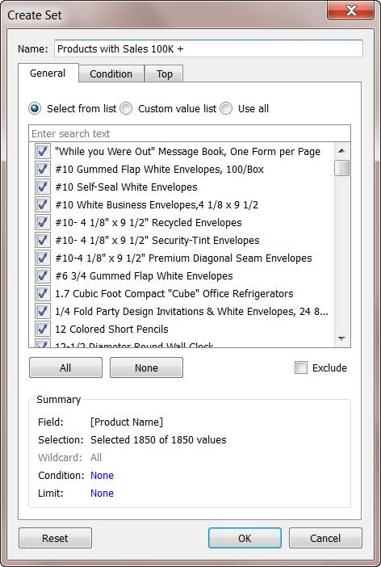
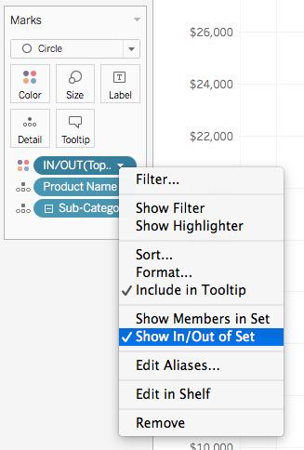

Creating Sets
Steps
- Right-click dimension
- Choose Create → Set
- Configure:
  - General
  - Condition
  - Top
- Click OK

IN/OUT Sets
IN
Data included in set.
OUT
Data excluded from set.
Example
Top 10 customers:
- IN → Top 10
- OUT → Remaining customers
Steps to Show IN/OUT
- Drag set to color shelf
- Tableau shows:
  - IN
  - OUT

5.4 Bins
What are Bins?
Bins group continuous values into ranges.
Example:
Age:
- 0–10
- 11–20
- 21–30
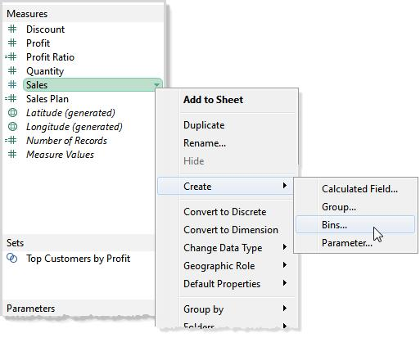
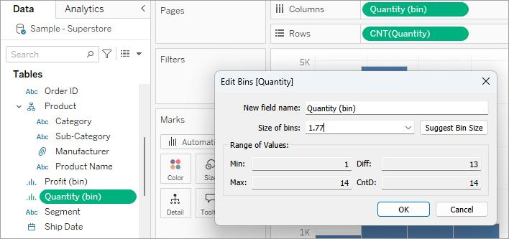
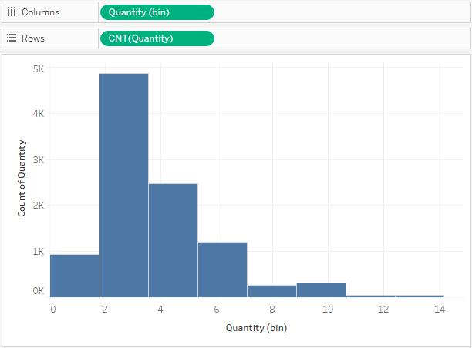
9

Steps to Create Bins
- Right-click measure
- Select Create → Bins
- Enter bin size
- Click OK
Example
Sales Bin Size = 1000
Uses
- Histograms
- Frequency analysis
- Distribution analysis

5.5 Hierarchies
What are Hierarchies?
Hierarchy organizes data levels for drill-down analysis.
Example:
Country → State → City
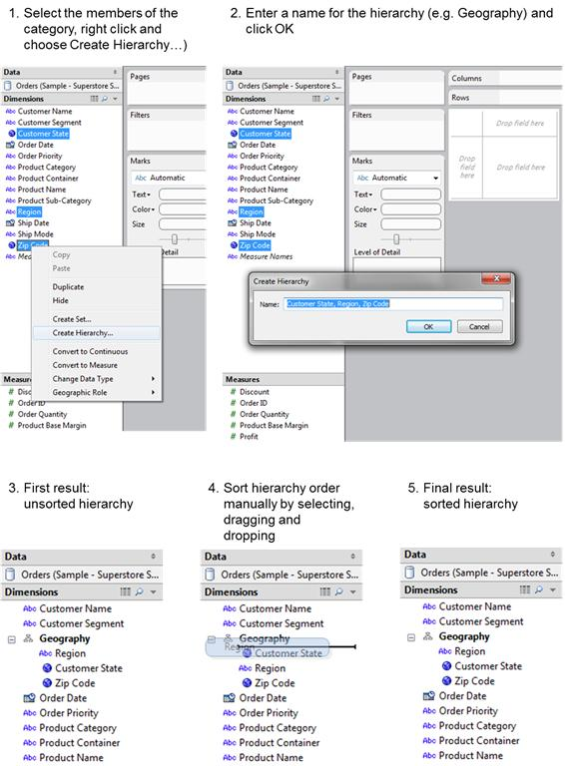
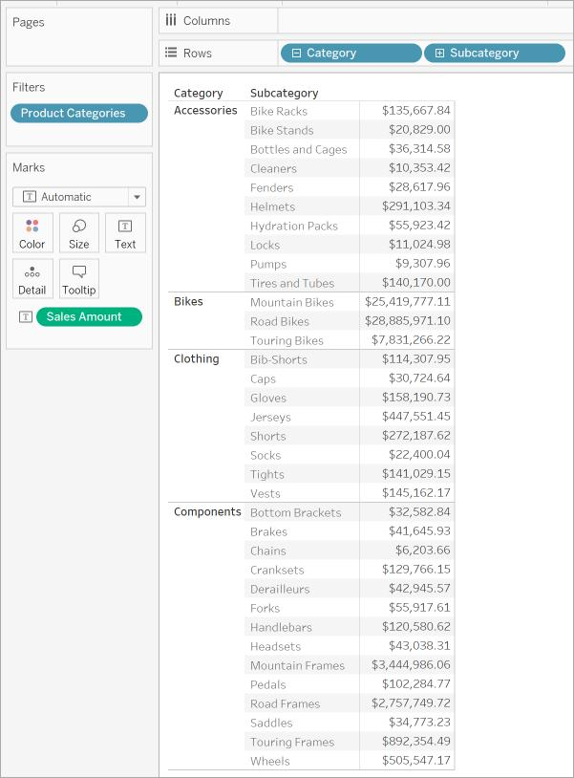
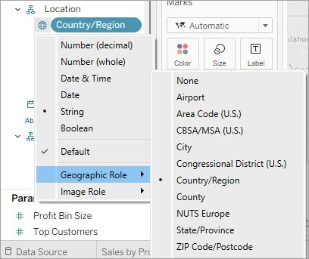

Steps to Create Hierarchy
- Select fields
- Right-click
- Click Hierarchy → Create Hierarchy
- Name hierarchy
- Add fields
Benefits
- Drill down
- Better navigation
- Structured analysis

5.6 Folders
What are Folders?
Folders organize fields in data pane.
Example:
- Sales Fields
- Customer Fields
- Product Fields
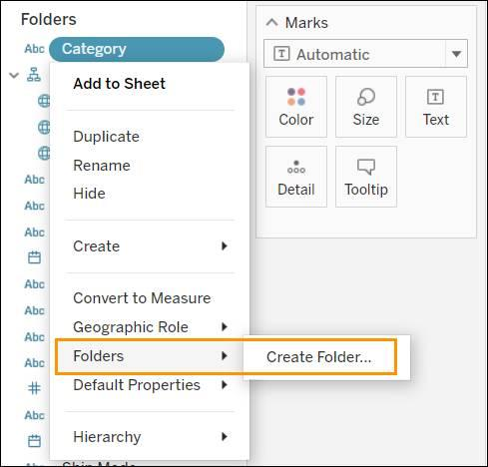
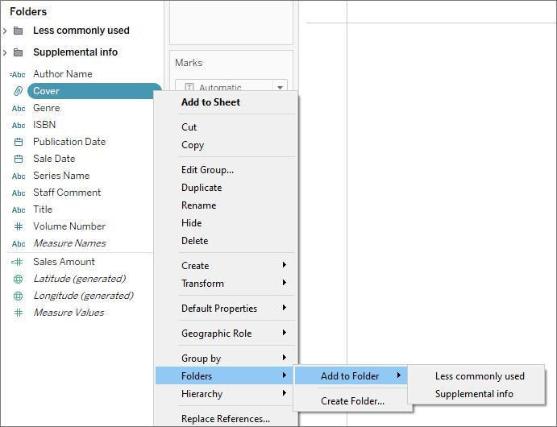
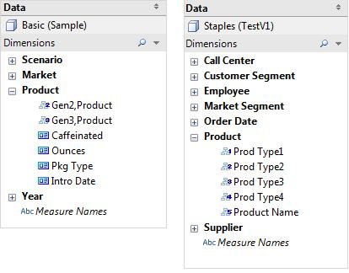

Steps to Create Folders
- Right-click field
- Select Folder → Create Folder
- Enter folder name
Benefits
- Better organization
- Easy navigation
- Clean workspace

5.7 Sorting and Types
Types of Sorting
1. Manual Sorting
Drag values manually.
2. Alphabetic Sorting
A to Z or Z to A
3. Field Sorting
Sort using another field.
4. Nested Sorting
Sorting inside categories.
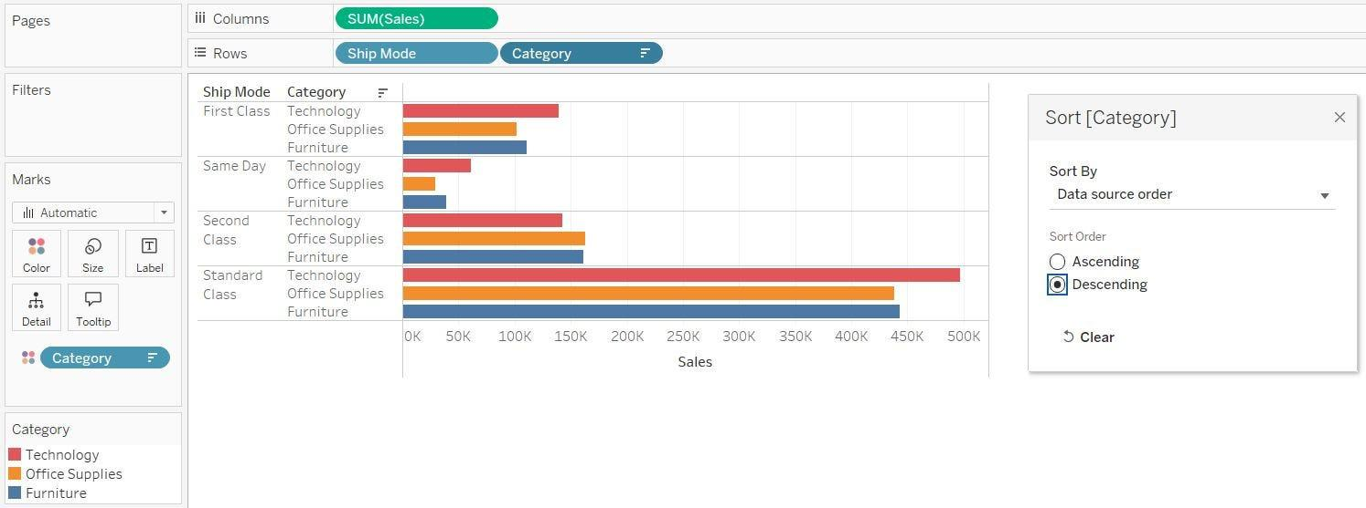
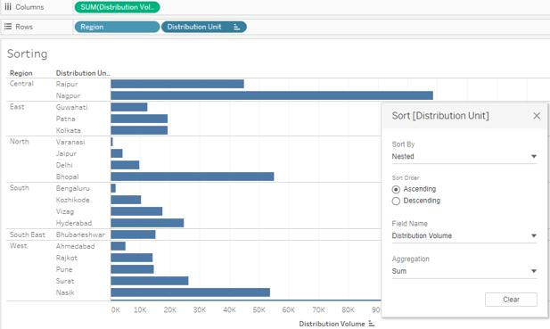
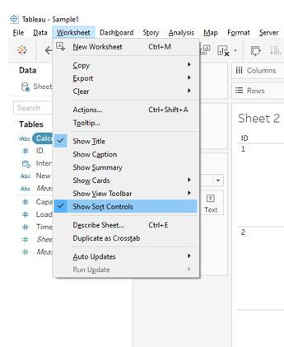

Steps for Sorting
- Select chart
- Click sort icon
- Choose:
  - Ascending
  - Descending
  - By field
Example
Sort products by sales.

5.8 Formatting Pane
What is Formatting Pane?
Formatting pane customizes workbook appearance.
You can format:
- Fonts
- Colors
- Borders
- Shading
- Alignment
- Numbers
- Pane settings
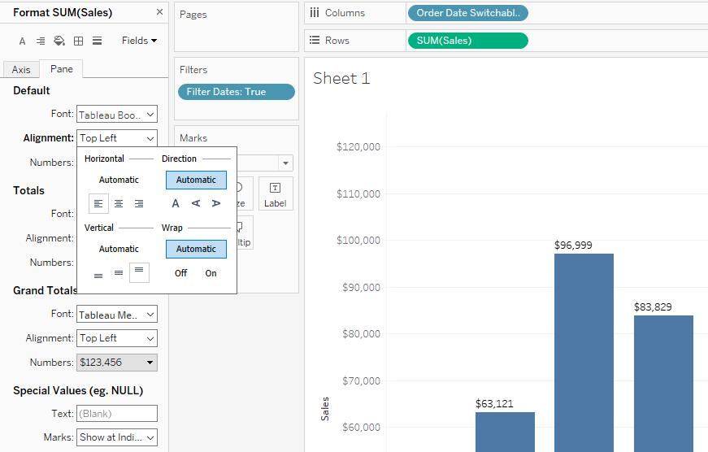
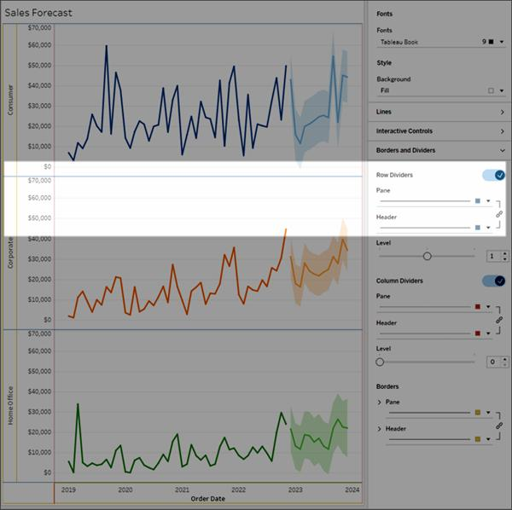
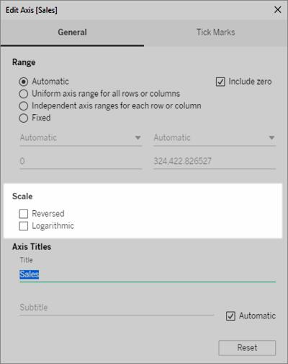
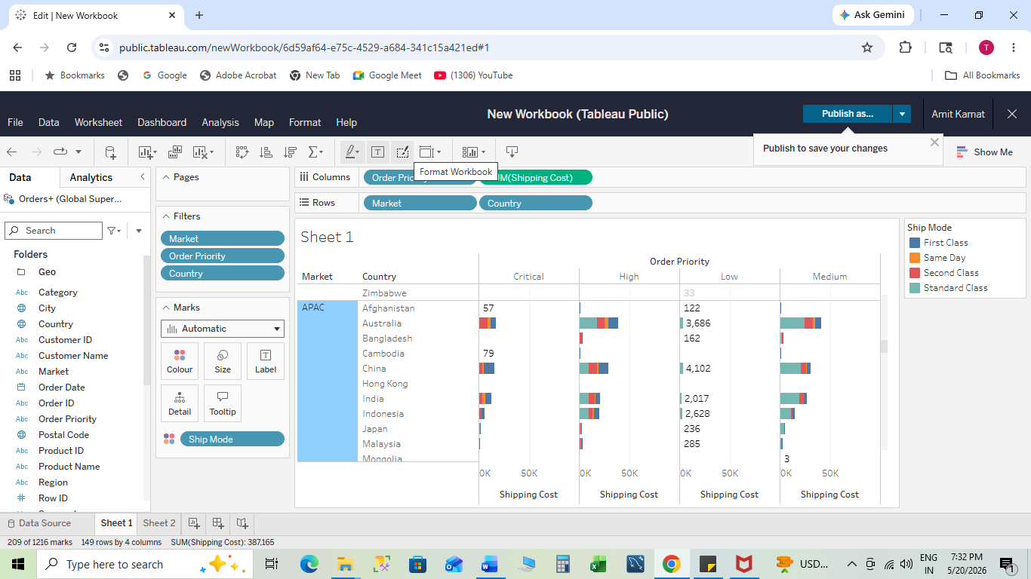
Steps to Use Formatting Pane
- Open worksheet
- Click Format
- Select formatting option

Common Formatting Options
Fonts
Change:
- Font style
- Size
- Color
Alignment
Align text:
- Left
- Center
- Right
Borders
Add borders to tables/charts.
Shading
Apply background colors.
Number Formatting
Customize:
- Currency
- Percentage
- Decimal places

5.9 Editing Axes and Annotations
Axes
What is Axis?
Axis represents measure scale in chart.
Example:
- X-axis = Category
- Y-axis = Sales

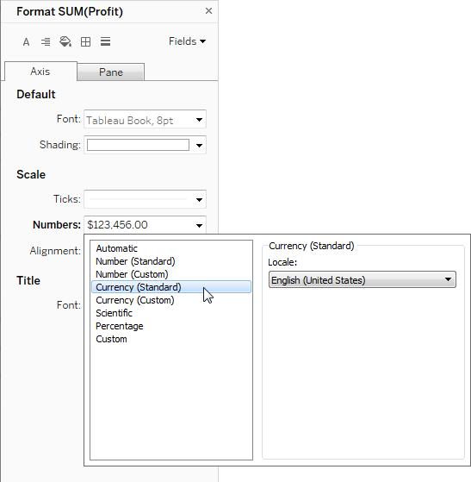
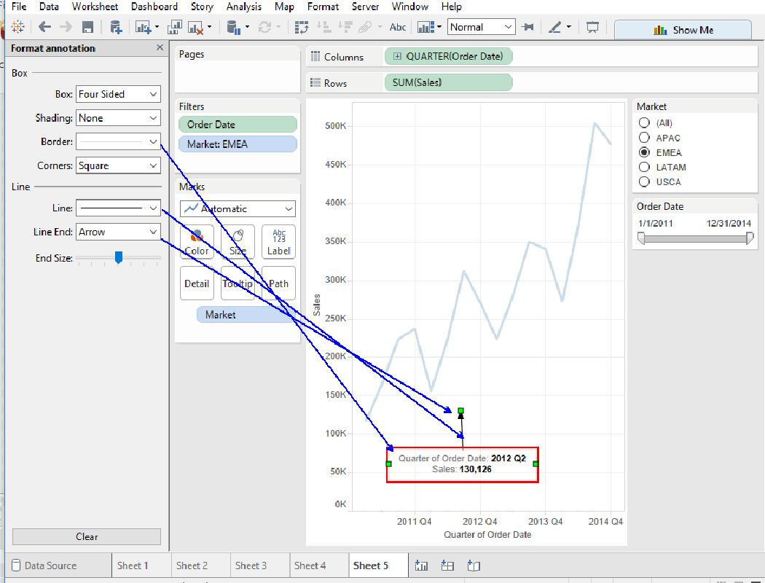

Steps to Edit Axis
- Right-click axis
- Select Edit Axis
- Modify:
  - Range
  - Scale
  - Title
  - Tick marks
Axis Options
- Fixed range
- Automatic range
- Logarithmic scale
- Reversed axis

Annotations
What are Annotations?
Annotations add comments or explanations to charts.
Types
- Mark Annotation
- Point Annotation
- Area Annotation

Steps to Add Annotation
- Right-click chart point
- Select Annotate
- Choose annotation type
- Enter text
Example
Highlight highest sales month.

Important Interview Questions
- What is the difference between Groups and Sets in Tableau?
- What are computed sets?
- Explain hierarchy with example.
- What are bins and their uses?
- Difference between IN and OUT in sets?
- How do annotations help in dashboards?
- What is the purpose of formatting pane?
- Explain types of sorting in Tableau.
- What is drill-down analysis?
- How do you edit axes in Tableau?

